

Saveetha Institute of Medical and Technical Sciences Chennai- 602105

Student Name: Durgi Lokesh Reg. No.: 192372216
Course Code: CSA1711 Slot: C
Course Name: Artificial Intelligence
Course Faculty: Dr. Krishna Kumar

Project Title: Design and Development of a Smart Waste Management System with Automated Trash Segregation
Module Photographs:
Review Output

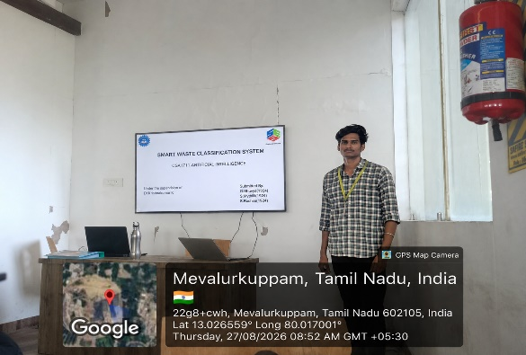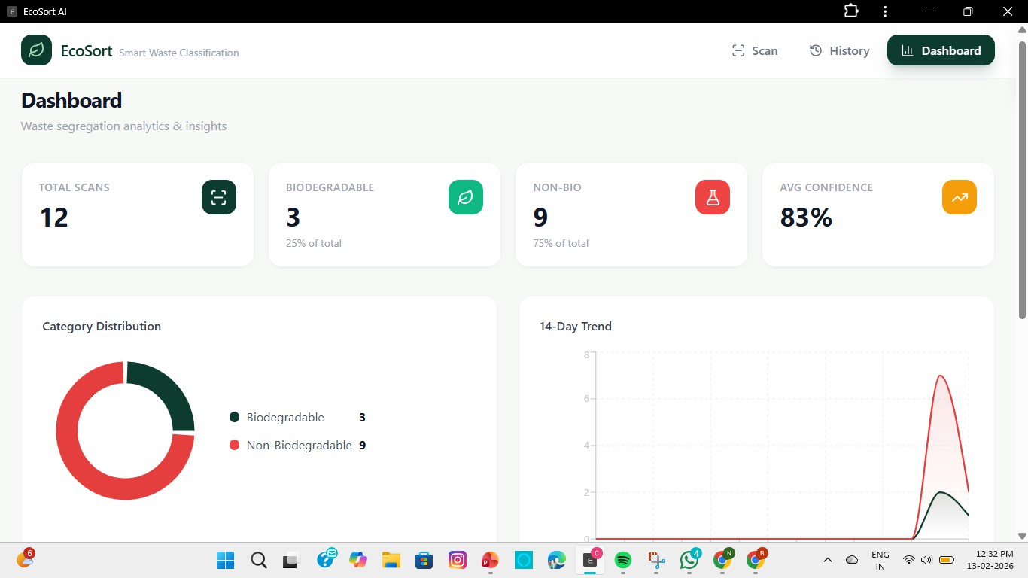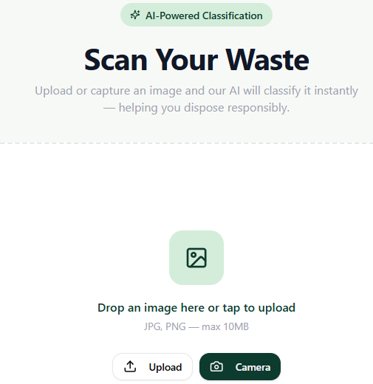

Project Description:
Module – AI-Based Waste Classification

Design and Development of a Smart Waste Management System with Automated Trash Segregation is an intelligent system designed to automatically identify and separate different types of waste. The system combines sensors, image processing, and artificial intelligence to detect waste and classify it into categories such as plastic, paper, metal, glass, and organic waste. This reduces manual effort, improves waste segregation efficiency, supports recycling, and helps maintain a cleaner and more sustainable environment.

The AI-Based Waste Classification module identifies the category of waste using a camera and an AI-based image classification model. The captured waste image is first preprocessed to improve its quality and then given to a trained Convolutional Neural Network (CNN) model. The model extracts important visual features and classifies the waste into predefined categories such as plastic, paper, metal, glass, or organic waste. The classification output is then used to control the automated segregation mechanism, ensuring that each waste item is placed in its appropriate collection bin.

Student Signature Guide Signature

